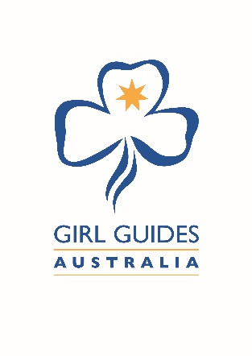

GIRL GUIDES AUSTRALIA PHOTOGRAPHIC AND

VIDEO CONSENT FORM

Publication of Photographs, Video, Audio Consent Form – Adult and Child

I, the undersigned person agree to and provide permission for the photographic, video, audio or any other form of electronic recording of me for and on behalf of Girl Guides Australia.

I authorise the use or reproduction of any image/recording referred to above for the purposes of publishing and online materials related to the activities, programs and services of Girl Guides Australia without acknowledgment and without being entitled to remuneration or compensation.

The image/recording may appear in print, electronic, or video media, and may be available to a global audience through the internet.

Images/recordings may also be provided to other Girl Guide State Office within Australia for use in related publications and online through the internet.

I acknowledge that ownership of any image/recording will be retained by Girl Guides Australia.

I understand and agree that if I wish to withdraw this authorisation, it will be my responsibility to inform Girl Guides Australia.

................................................................................. ...................................................................................
Signature of participant Signature of parent/guardian (if child under 18)

................................................................................ ................................................................................... Print name Print name

............................................................................... ...................................................................................
Email Contact Number

PLEASE RETURN THIS FORM to:

Email: or

Post to:

